The Where Project
Eric Long
720
The Where Project
Aluminum + Plastic = Flight
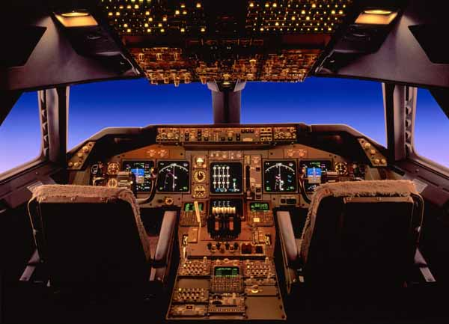

The Boeing 747 is one of the biggest airplanes in the world. It can carry 500 people half way around the world. There are over 1000 flying right now. It’s one of the best airplanes in the world.
This is the story how this airplane was made. I am going to tell you about 2 main parts of the aircraft. Without these two components, the 747 couldn’t fly. In fact, without these two components, flight as we know it would not exist. These main components are aluminum and plastic. Their light weight and strength allow huge aircraft to fly. Even the Wright brothers’ plane had an aluminum engine block.

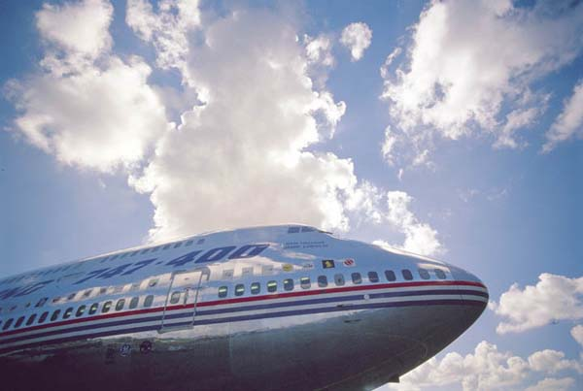
Boeing 747

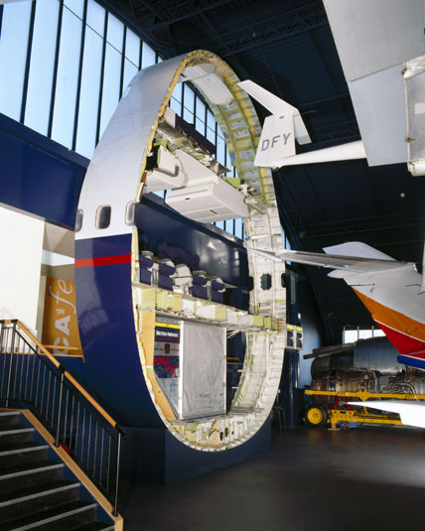
A thin slice of a Boeing 747 showing how much plastic and aluminum are required.

The top hull of a 747being assembled
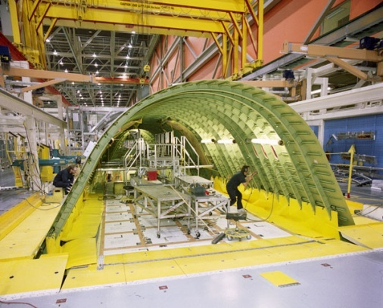
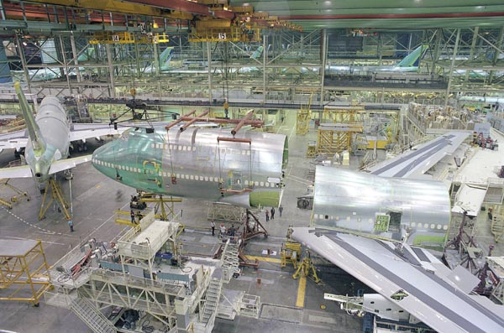
The largest building in the world is the Boeing assembly plant in Seattle.
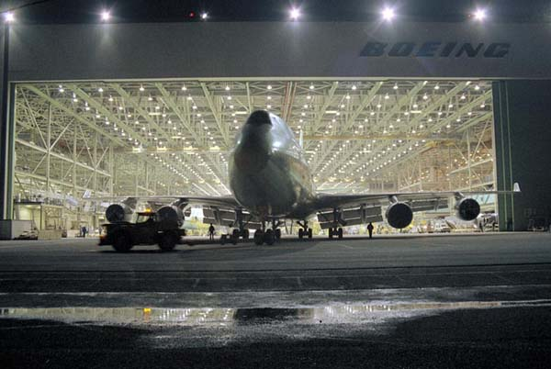
The final product consists of over 6,000,000 parts.
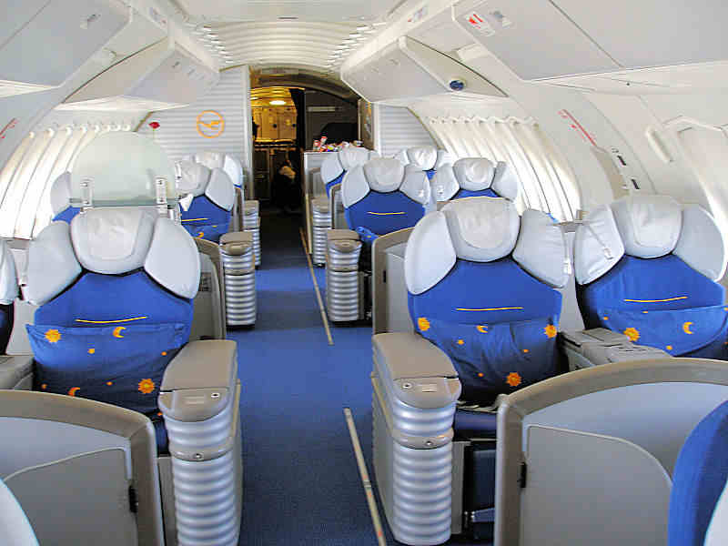
The inside of the 747 is mostly plastic.
Aluminum
The main component in an aircraft is aluminum because it is light and strong. The process uses a lot of energy, from smelting to welding the final piece to the airplanes.
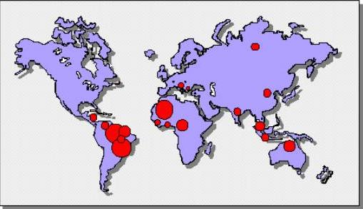
Bauxite is the main component of Aluminum, and comes from around the world, mainly Russia, Indonesia, Australia, Africa and South America.
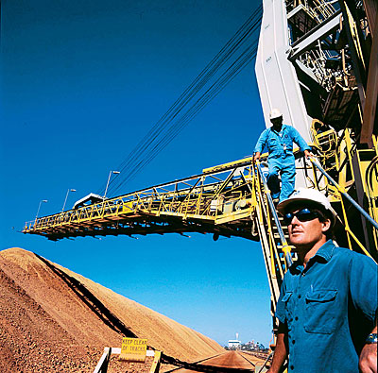Bauxite mine in Australia
Bauxite is plentiful enough to last for many centuries to come, but recycling is still important. Recycling requires only 5% of the energy needed to create a similar amount of new aluminum.

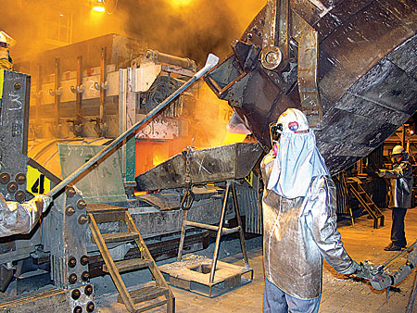Smelter in Washington

The main process to create Aluminum needs lots of energy. First a machine crushes the raw ore. Then it is ground up into a pulp. Then it goes into a furnace to refine the aluminum.
Of course all this takes more and more energy!

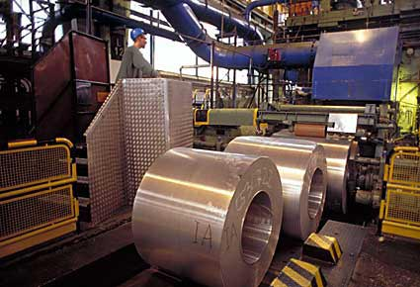Rolled Aluminum in Hungary
Then it gets smoothed out into rolls or bars and sent around the world by ship and rail, which takes even more energy. They say in the future though they say the energy will be reduced by 25% in the smelting procedure.
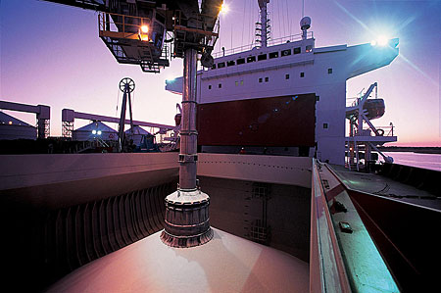Alumina being loaded aboard a freighter

Plastic
One of the most important parts of the airplane is the plastic on inside of the passenger cabin. Its super light weight helps makes it easier to build big planes.
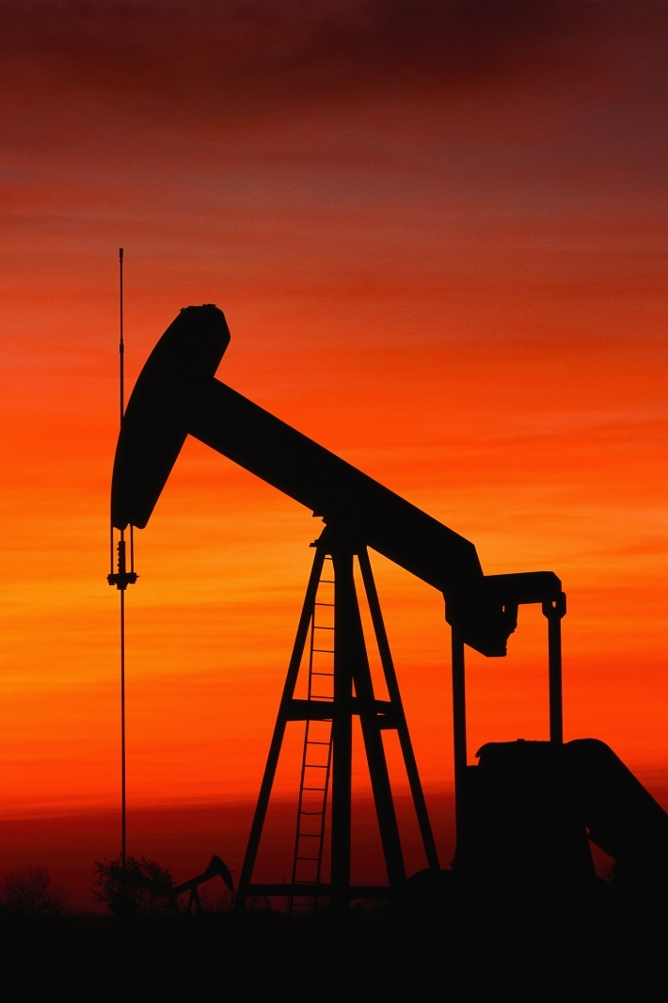Pump jack
Plastic comes from all over the world, pretty much all places where oil is made. China, Canada, Saudi Arabia and the USA are all major producers of plastic
Plastic is made from is petroleum. The petroleum is drilled and piped to a refinery where plastic pellets are made and shipped around the world to manufacturers.

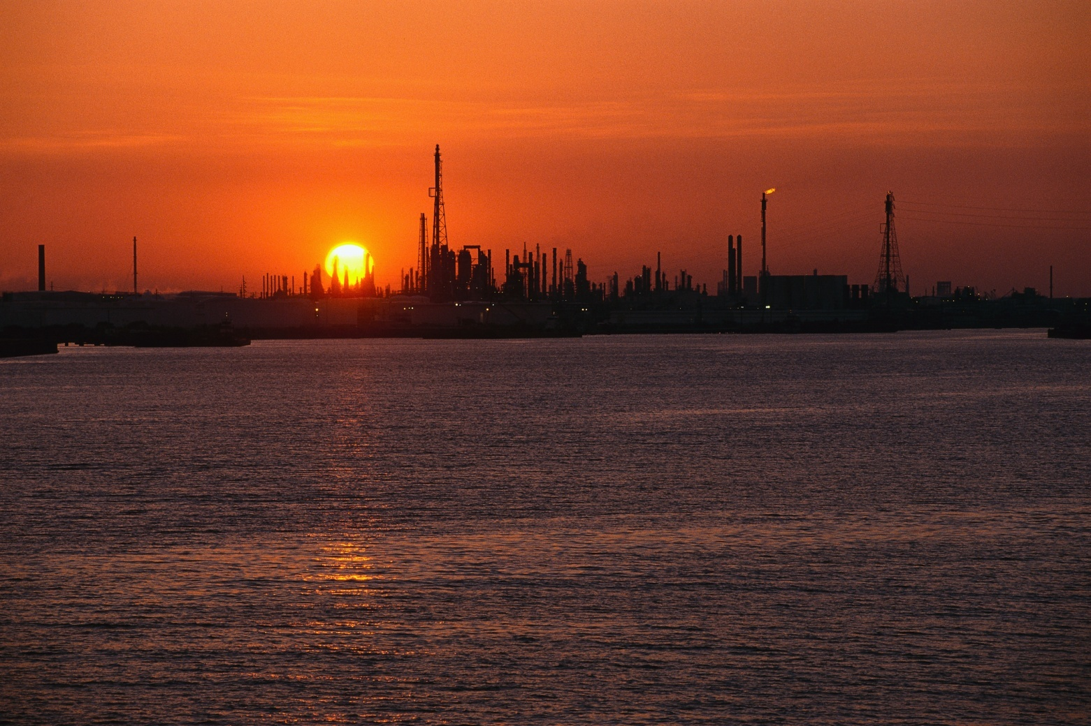
An oil refinery

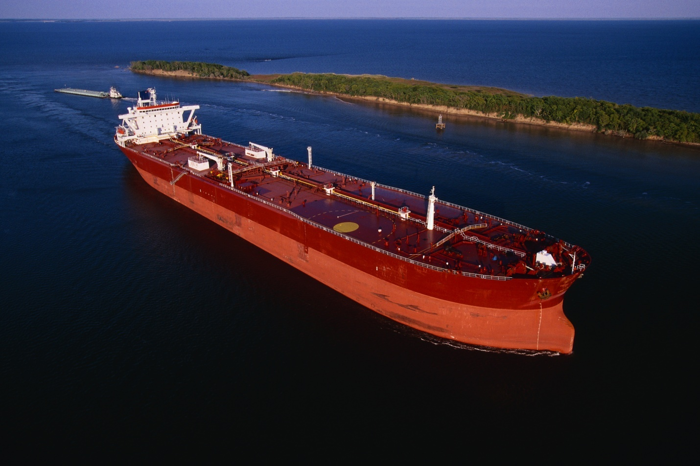
Oil and plastic ships around the world.

The manufacturers then make it into thousands of different products. It is put into the furnace where everything is melted, then put into a mould to make the product. Airplane parts are custom to fit to the airplane. Then the parts are shipped across the world to Boeing.

The 747 flies majestically off into the sunset thanks to the two main components that are taped, riveted, glued and welded onto the monstrous beast.

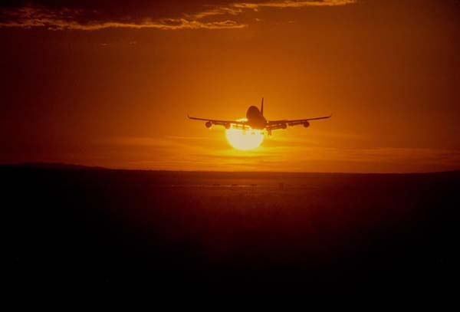

Bibliography
www.alcoa.com, February 22, 2008
www.boeing.com February 21, 2008
sam.davyson.com, Aluminum, February, 23, 2008
riotintoalcan.com, February, 23, 2008
life without plastic.com, Facts about Plastic, February 26, 2008

Photo credits
All aircraft photos printed with permission of Boeing.
All aluminum photos printed with permission of Alcoa.
All other photos rights free.

