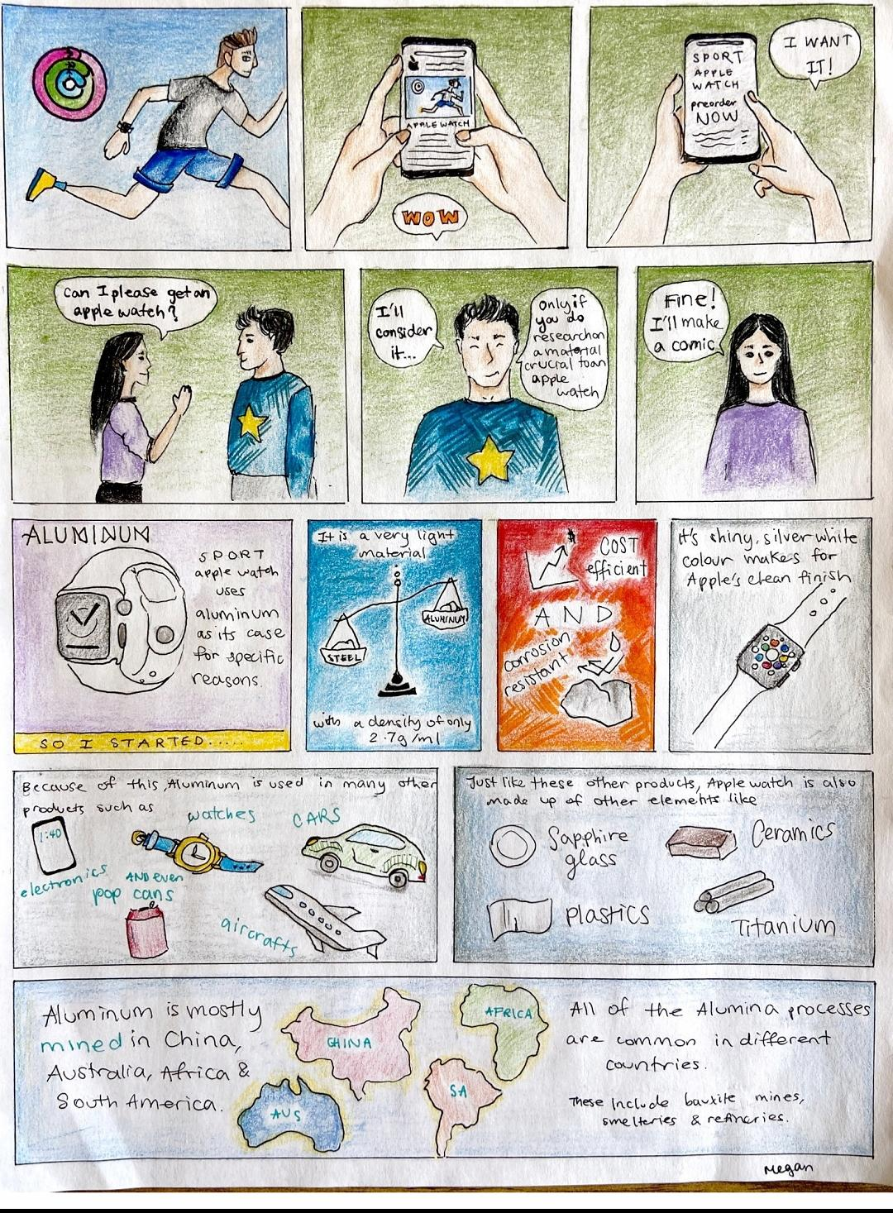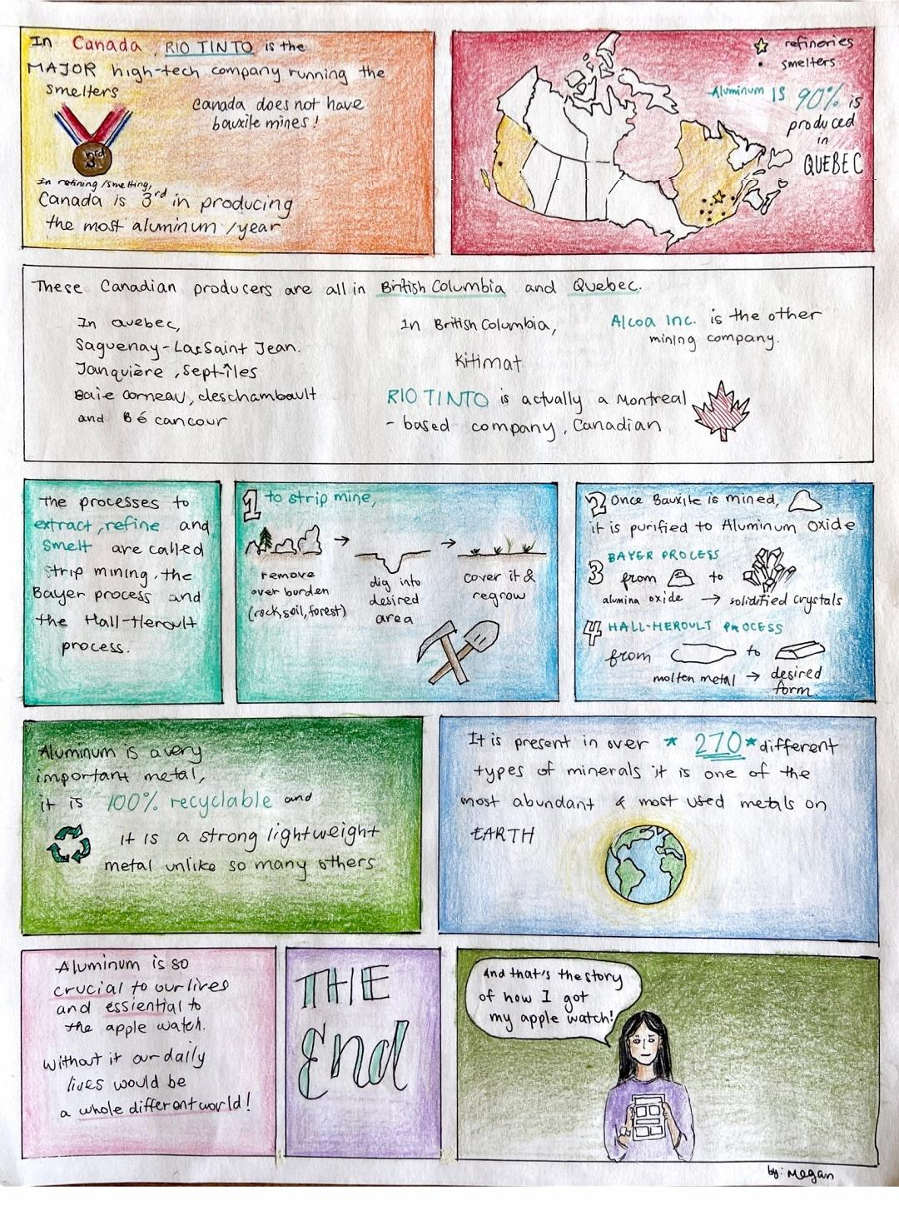

References

Advameg. (2020). “Aluminum”. Made How. Retrieved from
http://www.madehow.com/Volume-5/Aluminum.html.

Aluminum (Al). (2020). “In Encyclopædia Britannica”. Retrieved from
https://school.eb.com/levels/high/article/aluminum/5954

Apple. (2020) “Apple Watch User Guide”. Apple. Retrieved from
https://support.apple.com/en-ca/guide/watch/apdcf2ff54e9/watchos.

Centre for Industry Education Collaboration. (2016). “Aluminum”. Essential Chemical
Industry. Retrieved from https://www.essentialchemicalindustry.org/metals/aluminium.html

Chevalier, P.(2015) "Aluminum". The Canadian Encyclopedia, Historica Canada.
https://www.thecanadianencyclopedia.ca/en/article/aluminum.

Donoghue, M. (2014) “Bauxite Mining and Alumina Refining”. American College of
Occupational and Environmental Medicine. Retrieved from
https://www.ncbi.nlm.nih.gov/pmc/articles/PMC4131932/

Harris, W. (2020). “How Aluminum Works”. How Stuff Works. Retrieved from
https://www.google.com/url?sa=t&source=web&rct=j&url=https://science.howstuffworks.com/aluminum2.htm&ved=2ahUKEwik5bXq_qPnAhUQ16wKHRHjB_cQFjADegQICxAK&usg=AOvVaw30h-FFKCqFQ8wsX_O8efPG.

Hornbacher, A. (2020). “Steel Vs Aluminum”. Wenzel Metal Spinning. Retrieved from
https://www.wenzelmetalspinning.com/steel-vs-aluminum.html.

Koenig, G. (2020) “How the Apple Watch is made”. Mashable. Retrieved from
https://mashable.com/2015/03/15/apple-watch-how-its-made/. Accessed 13 January 2020.

Metal Supermarkets. (2015). “Aluminum and the Auto Industry”. Metal Supermarkets.
Retrieved from
https://www.google.com/url?sa=t&source=web&rct=j&url=https://www.metalsupermarkets.com/aluminum-and-the-auto-industry/&ved=2ahUKEwibyp22-6PnAhUj1VkKHfX7Cx8QFjAFegQIDRAW&usg=AOvVaw37Eu8F7ZE4L4JTih0DjOKN.

Mines Canada. (2017) “Mining in Canada”. The Canadian Minerals and Metals Plan.
Retrieved from
https://www.minescanada.ca/en/content/mining-canada-0.

Natural Resources Canada. (2019) “Aluminum Facts”. Natural Resources Canada.
Retrieved from
https://www.nrcan.gc.ca/our-natural-resources/minerals-mining/minerals-metals-facts/aluminum-facts/20510.

Newton, D. E. (2010). “Aluminum”. In K. J. Edgar (Ed.), Chemical Elements (2nd ed.,
Vol. 1, pp. 5-13). Detroit, MI: UXL. Retrieved from https://link.gale.com/apps/doc/CX3012400013/GVRL?u=ko_k12hs_d63&sid=GVRL&xid=d81378e6

Ophardt, C. (2003) “Aluminum, Al”. Virtual Chembook. Retrieved from
http://chemistry.elmhurst.edu/vchembook/102aluminum.html.

Rio Tinto. (2020). “Aluminum”. Rio Tinto. Retrieved from
https://www.riotinto.com/en/products/Aluminium.

The Aluminum Association. (2020) “Aluminum 101”. The Aluminum Association.
Retrieved from
https://www.google.ca/url?sa=t&rct=j&q=&esrc=s&source=web&cd=6&ved=2ahUKEwiaweOstZXnAhUTVc0KHTxvCeoQFjAFegQICxAW&url=https%3A%2F%2Fwww.aluminum.org%2Faluminum-advantage%2Faluminum-101&usg=AOvVaw31EkEt2MagrUPhJsUvYA8p

The Aluminum Association. (2020). “Electrical”. The Aluminum Association”. Retrieved
from https://www.aluminum.org/product-markets/electrical.

Woollaston, V. (2015) “Take a Peek Inside the Apple Watch”. Daily Mail. Retrieved
from https://www.dailymail.co.uk/sciencetech/article-3030492/Take-peek-inside-Apple-Watch-Infographic-reveals-firm-packs-components-needed-power-wearable.html.

